 

|  |  |
| --- | --- |
| **Project Name** | **Life Link.** |
| **Instructor Name** | **Murtaza Mahmood** |
| **Group Members** | **Mr. Muhammad Huzaifa Siddiqui.**  **Mr. Muhammad Ghazali Raza**  **Mr. Mustajab javed**  **Mr. Syed Sameer Ali.** |

DOCUMENTATION

**ACKNOWLEDGMENT**

We are really grateful because we managed to complete our E-project within the time given by our teacher

**Prof. Maaz Hassan**. This assignment cannot be completed without the effort and co-operation from our teacher, Group members; **Mr. Muhammad Huzaifa Siddiqui, Mr. Muhammad Ghazali Raza, Mr. Mustajab Rafay & Mr. Syed Sameer Ali.**

We also sincerely thank our teacher **Prof. Maaz Hassan** for the guidance and encouragement in finishing this project and also for teaching us in this course.

Last but not the least, we would like to express we gratitude to our friends and respondents for the support and willingness directly or indirectly to spend some times with me to fill in the questionnaires.

Contents

1) Introduction 4

2) Objectives of the project 5

3) Problem Statement 6

1) Home Page: 6

2) About Us Page: 7

3) Image Gallery: 7

4) Search, Sort, and Filter menus: 7

5) eAmbulance Type: 7

6) Feedback: 7

7) Contact Us: 7

8) Site map 8

9) WORK ANALYSIS 8

10) Header 9

11) Emergency Button: 9

12) Footer: 9

1) Home Page. 10

2) eAmbulance Types 11

3) Gallery. 12

4) Contact Us. 13

5) About Us. 14

6) Side map 15

7) Feedback Page. 16

8) Our Journey 17

10) Service Coverage Areas. 18

11) Location Page. 18

# Introduction

* Aptech has been one of the front-runners in the I.T. education space. In order to make learning interactive and exciting, Aptech Metro Star Gate initiated Contest-Azm in 2020.
* Contest-Azm is an IT competition which test the skills, proficiency, time, and team management skills of students.
* Help students experience the real-world environment, working in teams and developing website and apps.
* There will be rewards for students. So, gear up for the ultimate tech face-off on a center level.

Keeping the above in mind and in tune with our constant endeavour to use Technology in our training model, we at Aptech have thought of revolutionizing the way our students learn and implement the concepts using tools themselves by providing a *live and synchronous Contest Azm 2025 learning environment!*

**So, what is this Contest Azm 2025?**

Contest Azm 2025 is a technology-based competition by Aptech Metro Star Gate, testing students’ software knowledge, technical skills, time management, and teamwork. It offers participants the chance to work on live projects, showcase talent, and win cash prizes while being evaluated by Aptech and industry experts.

The students at the centre are expected to complete this Contest Azm 2025 and send complete project along with the documentation to Contes Azm 2025 Team

Looking forward to a positive response from your end!!

# Objectives of the project

* To help students experience the real-world environment, working in teams or individually within timelines.
* To give students an opportunity to work on a live project and create something new independently.
* To engage students with a competition

creating enthusiasm and interest.

# Problem Statement

A well-designed Website can foster customer engagement and loyalty by offering the best and fastest **eAmbulances** at critical times. This engagement strengthens the relationship between the customer and emergency services, thereby leveraging technology to provide rapid, efficient, and life-saving assistance to individuals.

**Proposed Solution.**

The proposed solution is a website called **'LifeLink'** for **eAmbulances**. The Website should enhance the efficiency and effectiveness of medical emergency services where users can browse and view different **eAmbulances** based on their requirements. It should also provide categories for different types of **eAmbulances**, offer sorting and filtering options, and allow users to search for a specific **eAmbulance**. Additionally, detailed information for each **eAmbulance** such as cost and availability should be displayed.

**Requirement Specification:**

The Web site is to be created based on the following requirements.

The portal will be designed as a Single-Page-Application (SPA) and a responsive website with a set of pages and menus that represent choice of activities to be performed. The pages, menus, and other visual elements must be designed in a visually appealing manner with attractive fonts, colours, and animations wherever applicable. All of these should also be laid out in a responsive manner.

Following are the functional requirements of the portal:

# Home Page:

The Website should allow users to browse through the catalogue and view individual **eAmbulance** listings.

# About Us Page:

Users should be able to view information about the company and creators of the site. The company information can include number of cities/regions served by them and best performing **eAmbulances**.

# Image Gallery:

Users should be able to view different **eAmbulance** images uploaded on the Website.

# Search, Sort, and Filter menus:

Users should be able to search for different types of **eAmbulances** and sort/filter them as per their requirements. One can search according to the area/region, for example, user can type ‘Chicago’ and it should display the **eAmbulances** available in this particular region. Sort and Filter should display based on user’s requirement such as costs or type of vehicle he/she wants.

# eAmbulance Type:

The **eAmbulance** type menu should display the type/kind of vehicle, size, and equipment along with its costs to the users. The menu can also include specialization of the **eAmbulance**, such as A/C or Non-A/C, ICU or ICCU, and so on.

**For example**, users can search based on price $12 so it should display the ambulances available for this cost range.

# Feedback:

The Feedback option should enable users to provide their feedback about the **eAmbulance** Website through a feedback form.

# Contact Us:

The Contact Us field should display the contact information of the creators of the Website. An email id and Contact Number can be displayed here.

# Site map

This document outlines the sitemap and core details of the eAmbulance – Emergency Medical Services website, including its purpose, target audience, key features, and individual page summaries.It serves as a structured guide to the website’s navigation, functionalities, and typical user journey for connecting patients with trained medical transport services.

# WORK ANALYSIS

|  |  |  |  |  |
| --- | --- | --- | --- | --- |
| Task | Huzaifa  Siddiqui | Ghazali raza | Mustajab  Jawed | Sameer  Ali |
| Analysis | **Yes** | **NO** | **Yes** | **No** |
| Design | **Yes** | **NO** | **Yes** | **No** |
| Coding | **Yes** | **No** | **Yes** | **NO** |
| Testing | **Yes** | **No** | **Yes** | **NO** |
| Documentation | **Yes** | **Yes** | **No** | **Yes** |

**Components:**

# 1)Header



# 2)Emergency Button:

**You can easily view your emergency contacts and response here by one click.**

# 3)Footer:

**Pages:**

## Home Page.

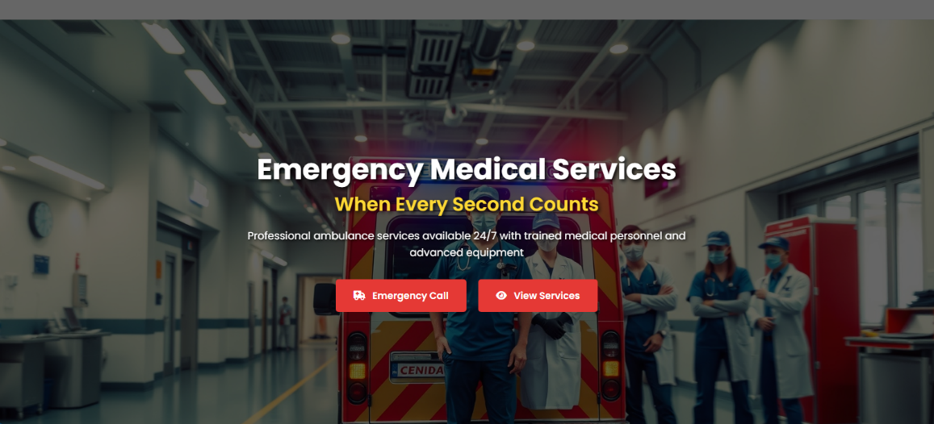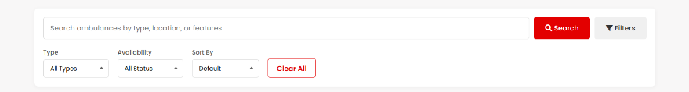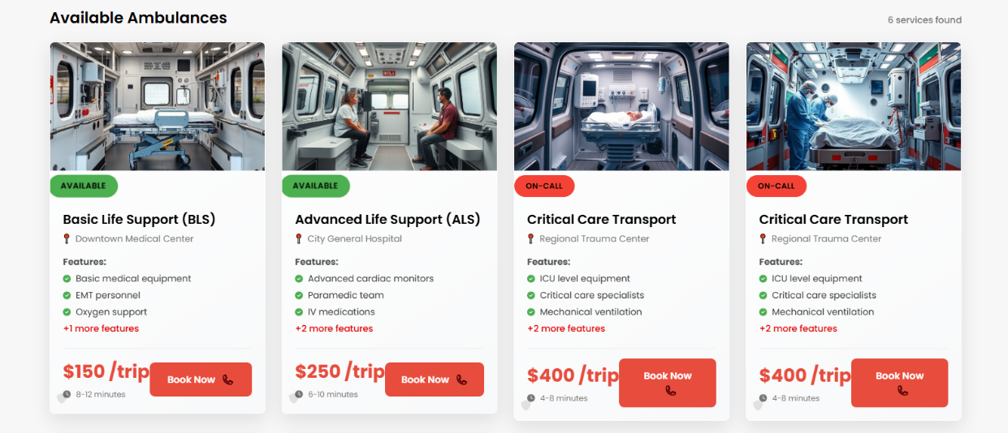

## eAmbulance Types

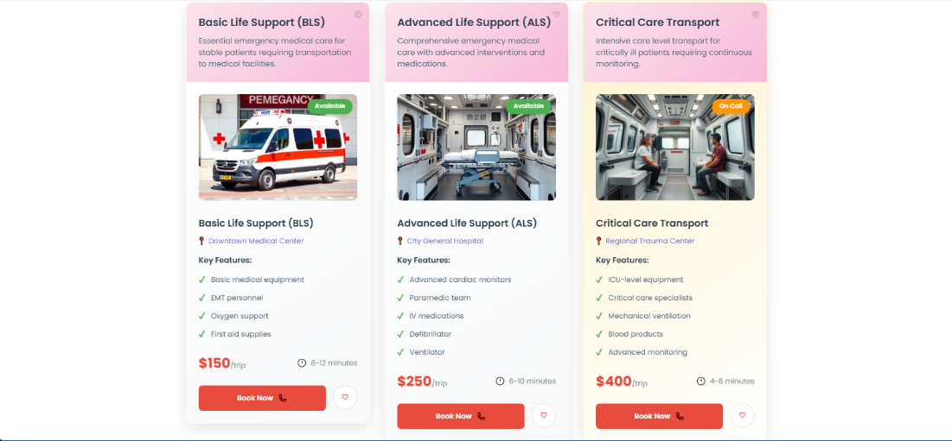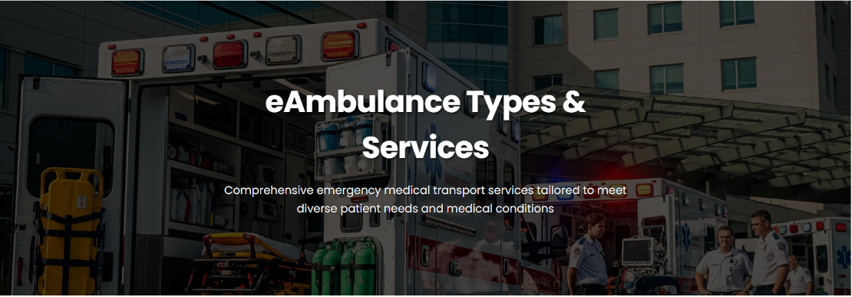You can Search a particular business eAmbulance type by selecting your required category from dropdown menu of business units.

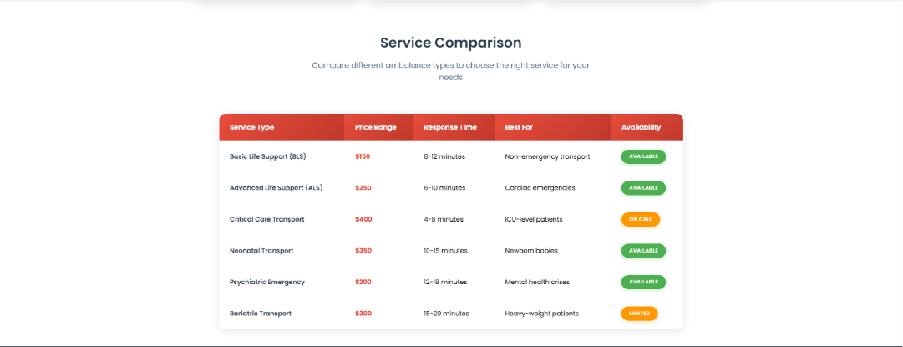

## Gallery.

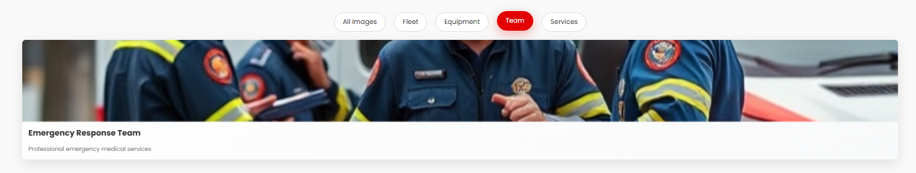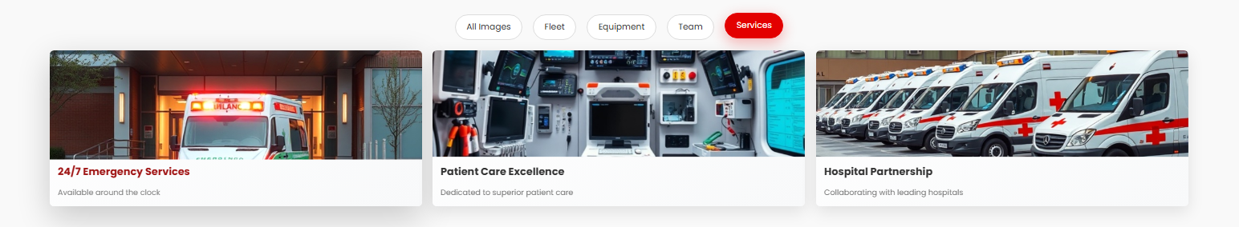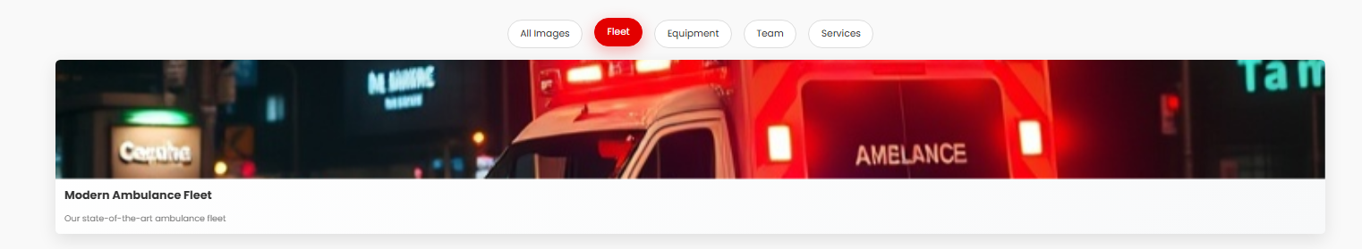

## Contact Us.

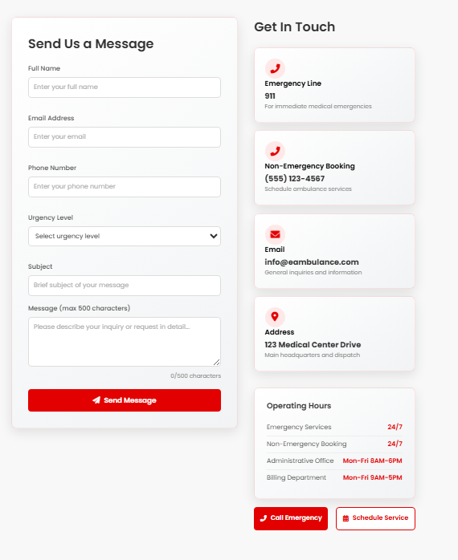

## About Us.

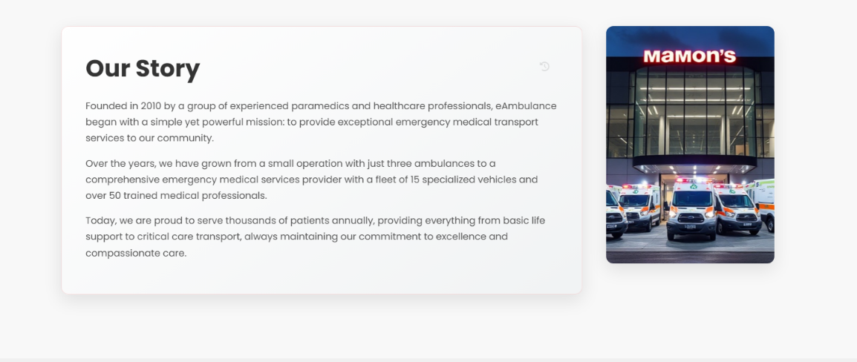

## 6) Side map

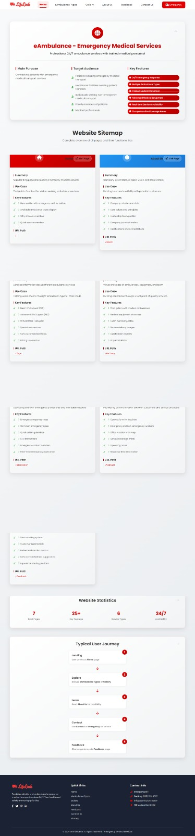

## 7) Feedback Page.

## 8) Our Journey

**9) Our Leadership Team and Our Certificate & Accreditations.**

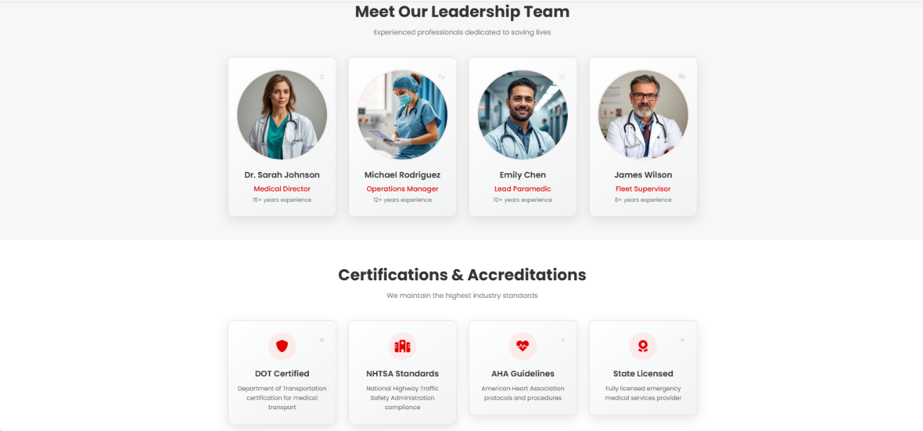

## 10) Service Coverage Areas.

## 11) Location Page.

**Thank You**